**Advanced Graphics Programming** Project 2 (Deferred rendering) - May 2020

| * The submission deadline is **May 17th at 23:59:59**. * Upload a .zip file with the solution and the assets necessary to show your results. |
| --- |

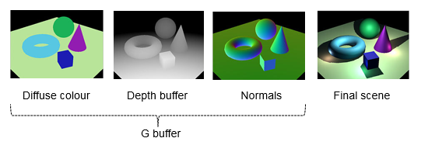

## Statement

Implement a deferred renderer as explained in class.

It will need to have implemented the following features:

* A scene composed of some 3D models
  + Models can be statically created and set up in the Init() function
  + No need for dynamic model loading
* A framebuffer object and several render targets (textures) attached to it in order to render the materials properties
  + Albedo
  + Normals
  + Position
  + Depth
* To put the technique to the test create a considerable amount of light entities:
  + A couple of directional lights:
    - Directional lights must be rendered as screen-filling quads
  + Several/many point lights distributed over the whole scene:
    - Point lights must be rendered as spheres
  + All lights entities can be created in the Init() function
* Using ImGui, create a combo box that allows us choosing to visualize among the different textures of the G-buffer of the final lit scene
* A simple WASD camera navigation mechanic will be very welcome...